«${currentDate?date?string('dd MMMM yyyy'»
MyCCA reference: «${workflow.requestId}»

Operator name: «${params.targetUnitDetails.name}»
«[#if (params.targetUnitDetails.companyRe»Company number: «${(params.targetUnitDetails.companyRegis»«[/#if]»
Address for service:
By post:
«${params.targetUnitDetails.location}»
Electronically:
«${params.targetUnitDetails.primaryContac»

The Climate Change Agreements (Administration) Regulations 2012 (As amended) (“THE REGULATIONS”)

Dear «${params.targetUnitDetails.primaryContac»,
We are writing to inform «${params.targetUnitDetails.name}» (“you”) that we«[#if (params.isRegulatorLed)]» completed «[#else]» accepted «[/#if]»the following changes to the information we hold about your underlying agreement(s) on «${currentDate?date?string('dd MMMM yyyy'»:
«${params.additionalInformation}»
This relates to the following underlying agreement(s) and account reference:
Underlying agreement identifier(s): | «[#if (params.versionMap?keys?seq_contain»«${account.targetUnitIdentifier}» CCA2 Underlying Agreement «${params.versionMap["CCA2"]}»«[/#if]»«[#if (params.versionMap?keys?seq_contain»  «[/#if]»«[#if (params.versionMap?keys?seq_contain»«${account.targetUnitIdentifier}» CCA3 Underlying Agreement «${params.versionMap["CCA3"]}»«[/#if]»
Target unit account details: | «${account.targetUnitIdentifier}»  «${params.targetUnitDetails.name}»  «${params.targetUnitDetails.targetUnitAdd»
As this variation does not change any of the information in the existing version of your underlying agreement(s), we are not updating these and do not need you to provide your assent.
If you require any clarification of the above, please contact your Sector Association in the first instance.
If you need to contact the Administrator for any supporting information, please use the following email address: cca-help@environment-agency.gov.uk
Yours faithfully
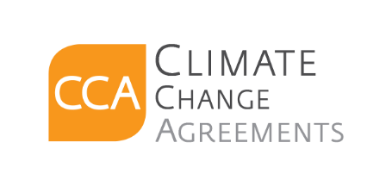
CCA Team

c.c. «[#list email.ccRecipients as cc]»«${cc}[#sep], [/#sep]»«[/#list]»

